**Experiment -1.2**

Install Git and creating repository.

**Student Name: Preet UID: 22BDO10062**

**Branch: CSE(DevOps) Section/Group**- **22BCD-1/B**

**Semester: 4th Date of Performance: 19/01/2024**

**Subject Name**: Git and hub **Subject Code: 22CSH-293**

**1. Aim/Overview of the practical:** Creating branches with GitHub.

**2. Software Used :** GitHub Online, Git Bash.

**3. Steps for experiment/practical:**

**Using GitHub,**

1. Go to GitHub.com and login with your credentials.
2. Go to your repository and click over main.
3. Now, enter the name of branch you want to create, I gave it “exp2”.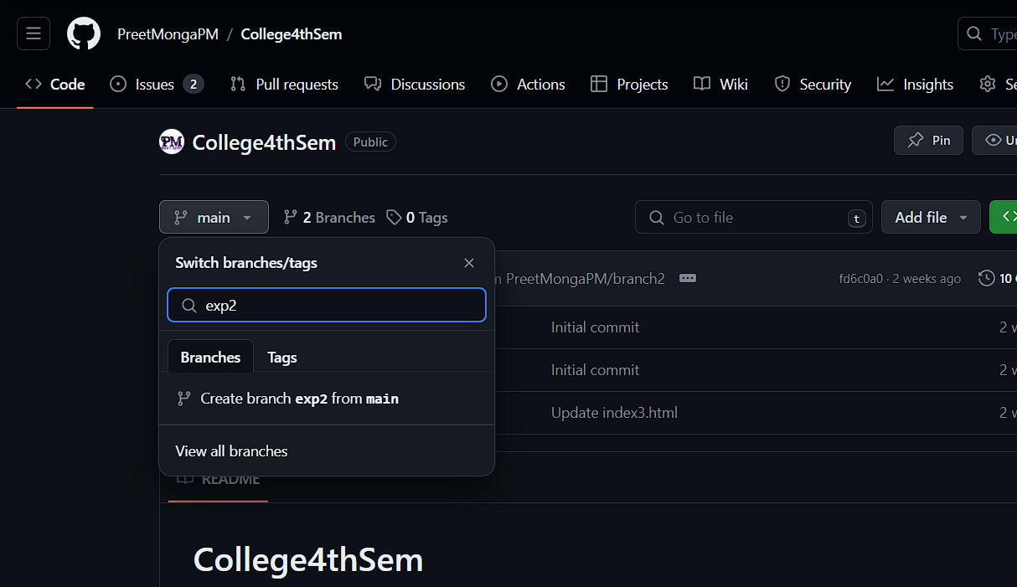 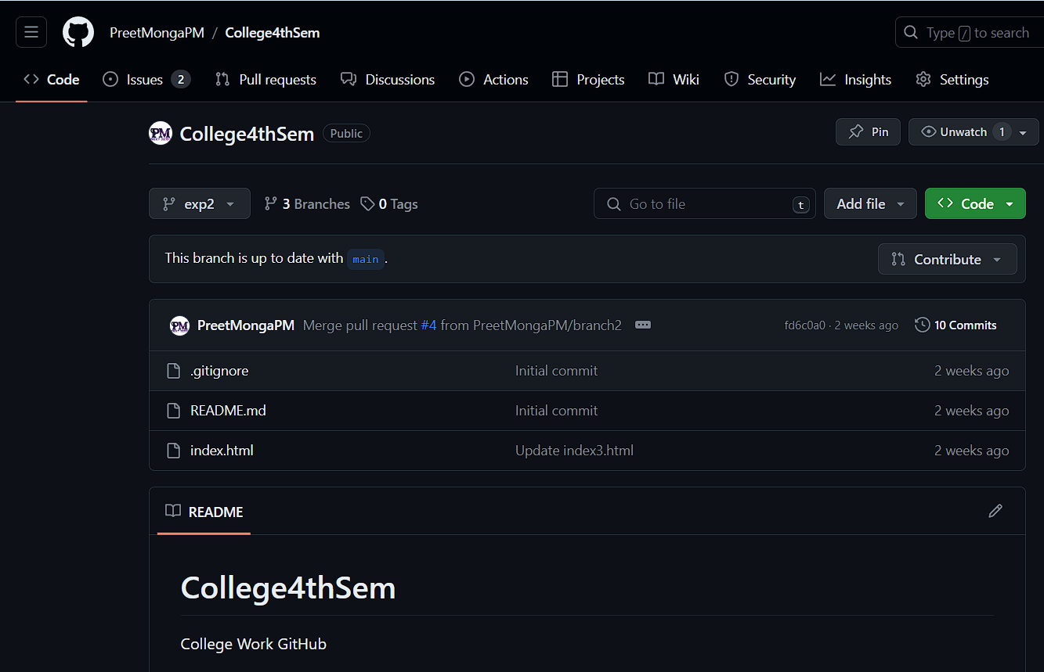
4. After entering the name click over create branch, we can see the created branch.
5. Now, let’s update something in the branch “exp2” files, let’s take index.html. Open index.html.
6. Click over edit button, the pencil icon over right-top corner to edit the file. 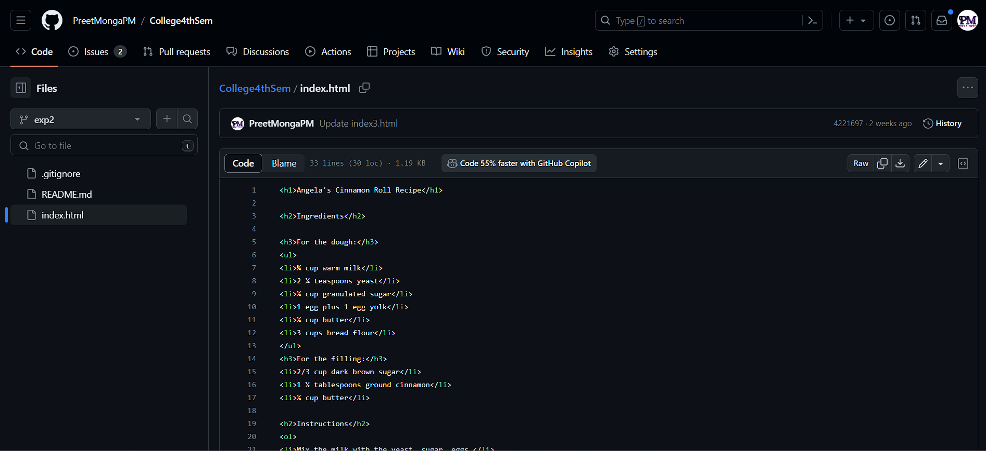 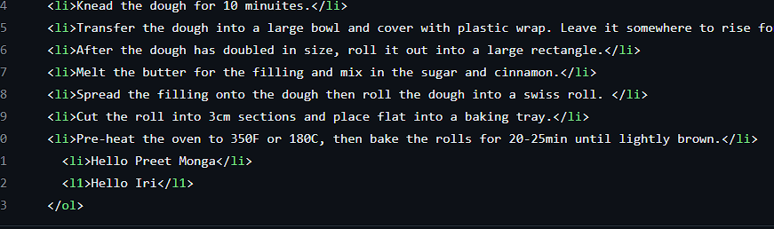
7. I am deleting the Monga from <li> Hello Preet Monga</li>.
8. Commit changes in this file, with your own commit message.

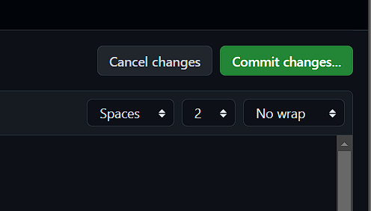 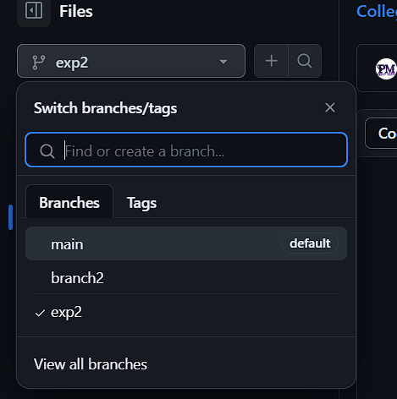

1. Head over to **main** branch by clicking on the Exp2.
2. Now, a popup of “Compare and Pull request” and it says “Exp2” had one recent push.

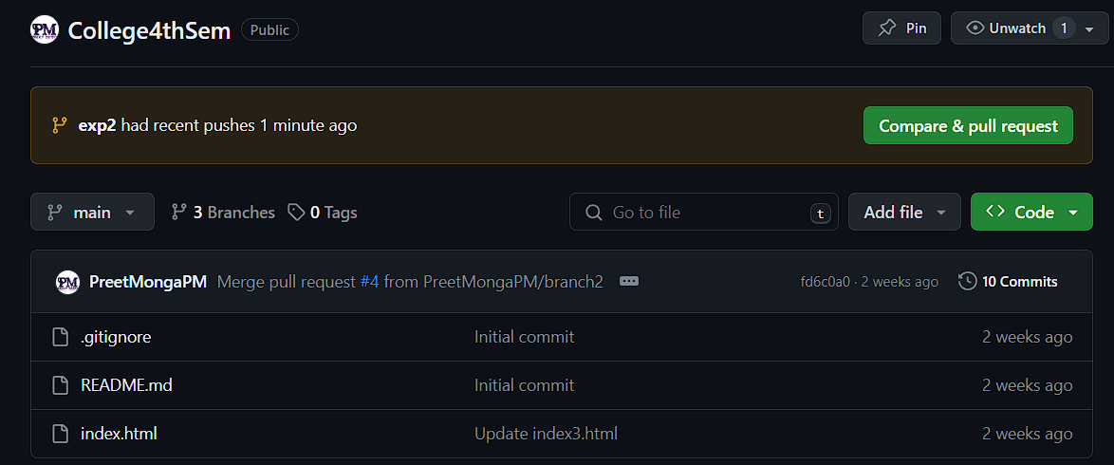 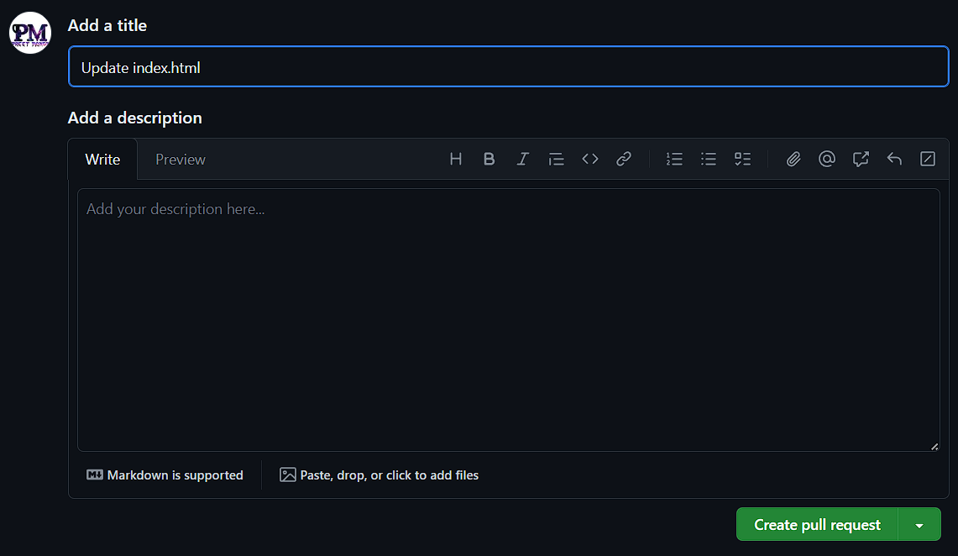

1. Now you can write your description or hover down a little to see the differences you have created in two ways – Split and unified.

**Split View :**

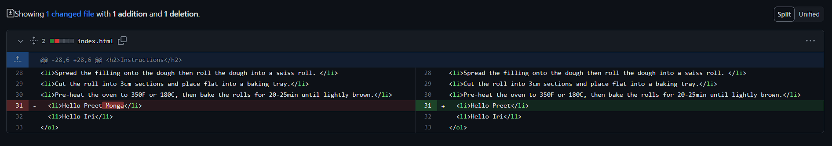

**Unified View:**

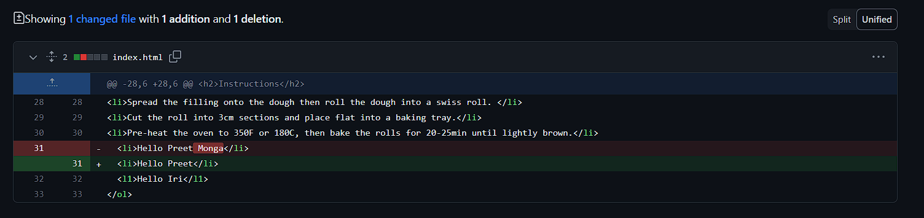

1. Here, we can see the changes, once you have verified the changes you go up and create pull request.
2. Then it will check if the GitHub can automatically merge the pull request, after verification click over the merge pull request and click over the merge request.

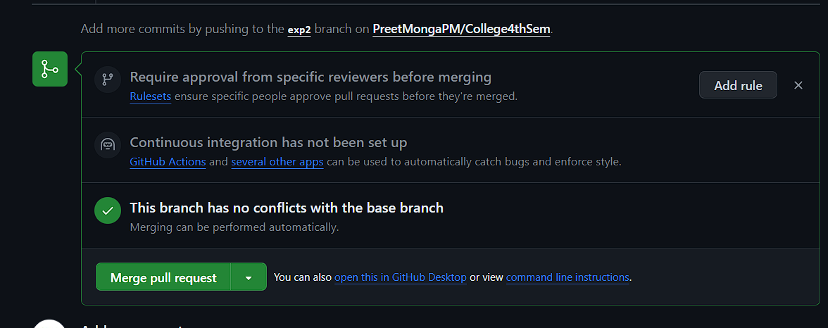 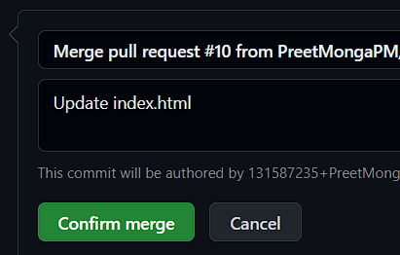

1. After merge it shows the following screen, then you can delete the branch if you want to.

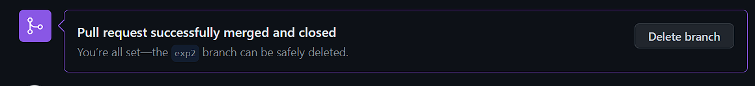

1. Click over “Delete branch” or you can delete over going to the all branches by clicking on the dustbin icon.

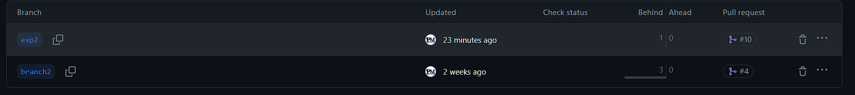

**Using Git Bash:**

1. Create a folder in local machine “GitCollege” and create a sub folder “exp2”.
2. Change the directory from GitCollege to exp2 using “cd” command.

*cd exp2*

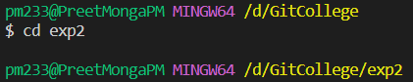

1. Initialise git in the folder using following:

*git init*

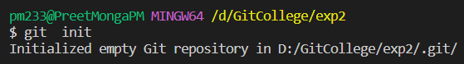

1. Now create a file in exp2 using **cat** command and write in the file then press enter and press ctrl+d to save the content on your file.

*cat > index.html*

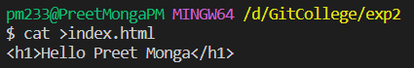

1. Check the status of git to see which files are untracked.

*git status*

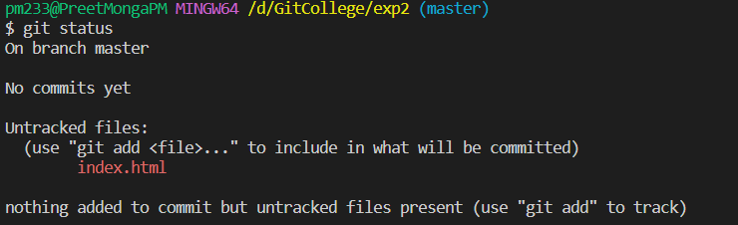

1. As we can see the index.html is not tracked so add it and then commit the changes, then again check the status of git.

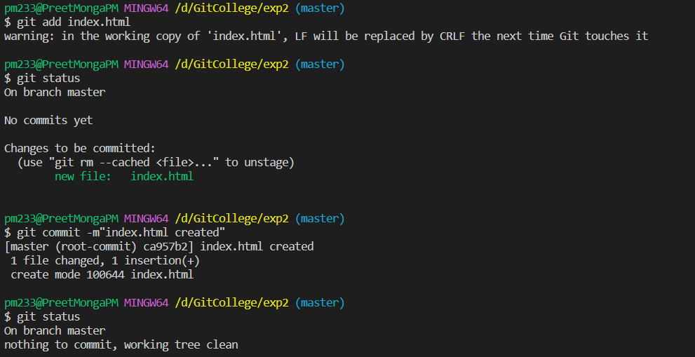

1. Now, let’s create a branch named “exp2”.

*git branch exp2*

*or*

*git checkout -b exp2* (it will also move your current branch to exp2)

1. We can also check the branch in which we are currently using :

*git branch*

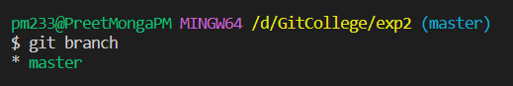

1. We can shift using 7th command or using

*git checkout branch_name*

*git checkout exp2*

1. Now we are inside exp2, do the same create a index.html and write a diff line, then add and commit.

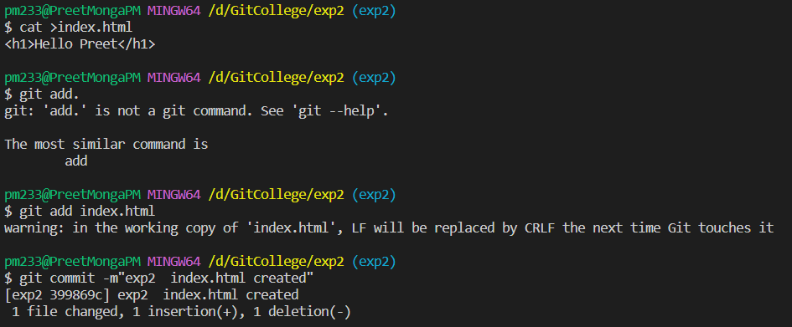

1. Go to master branch using :

*git checkout master*

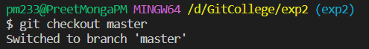

1. Now we can also see all branches using :

*git branch*

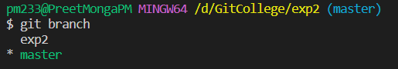

1. Now let’s compare our master branch with the exp2 branch using :

*git diff second_branch_name*

*git diff exp2*

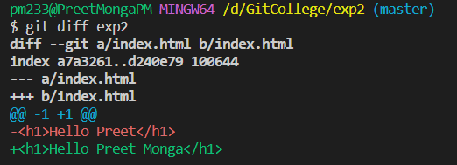

1. All the differences are shown above, now let’s merge using:

*git merge second_branch_name*

*git merge exp2*

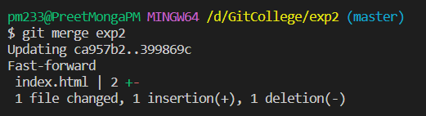

It fast forwarded itself to keep exp2 changes, and also we can do it manually in vs code when we push it.

1. Now, let’s again check the difference with the master branch using:

*git diff exp2*

nothing is shown so no differences are there and merged successfully.



1. Now, let’s delete the second branch using :   
   *git branch -d exp2*

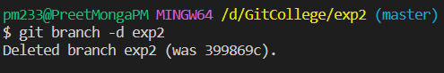

1. We can see present branches using :

*git branch*

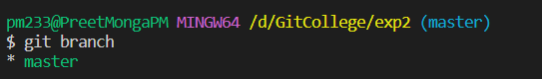We can see there is no exp2 branch now.

We have created, merged and deleted the branch over both GitHub and Git Bash successfully.

**4. Result/Output/Writing Summary:**

In the end we can see that first we created the branch in GitHub then merged it using pull request and also we created the branch using Git Bash and merged. We deleted branches at both places successfully at the end so that it may confuse the developer in the end.

**Learning outcomes (What I have learnt):**

**1.** Learnt about using GitHub and Git Bash.

**2.** Learnt about creating branches over both.

**3.** Learnt about merging the branches and resolving conflicts.

**4.** Learnt about deleting the branches.

**5.** Learnt about shifting from one branch to other.

**Evaluation Grid (To be created as per the SOP and Assessment guidelines by the faculty):**

|  |  |  |  |
| --- | --- | --- | --- |
| Sr. No. | Parameters | Marks Obtained | Maximum Marks |
| 1. |  |  |  |
| 2. |  |  |  |
| 3. |  |  |  |
|  |  |  |  |